**Virtual Key for Your Repositories**

Assessment: Project 1

Developer : Rohit.P

**Product requirements and capabilities:**

A vision to create end user interactive applications meeting the requirements of creating files dynamically suggested by the end user, retrieving, deletion of files and searching for particular files in the specified directory.

**Appearance**

The applications projects a listed wizard , in which options are :

1. to show existing files
2. perform file operations(adding, deleting, searching)
3. existing from the application

**User interactions:**

As the java files complies the ide console window shows Welcome screen and developer details and options as below Snippet

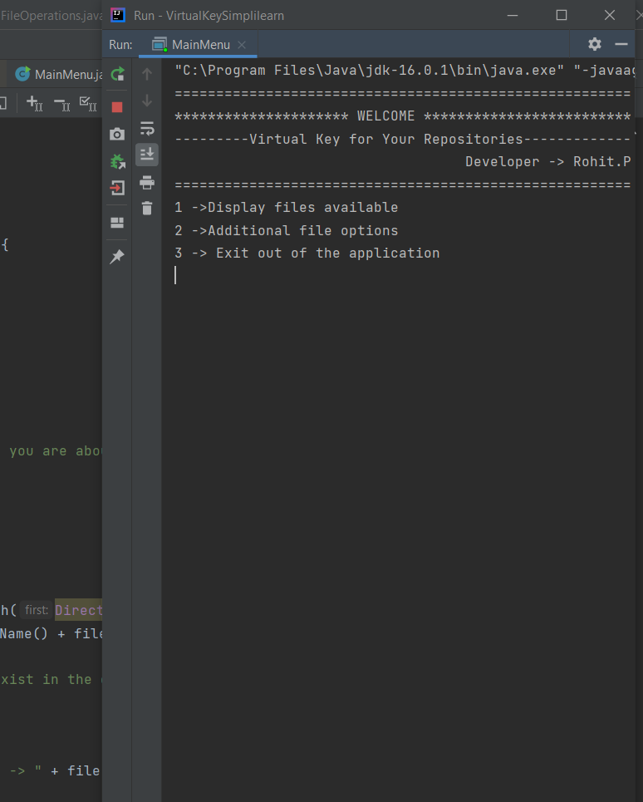

As the first options is selected it displays are the files that are present in the defaulted path: “main\Saved_texts”

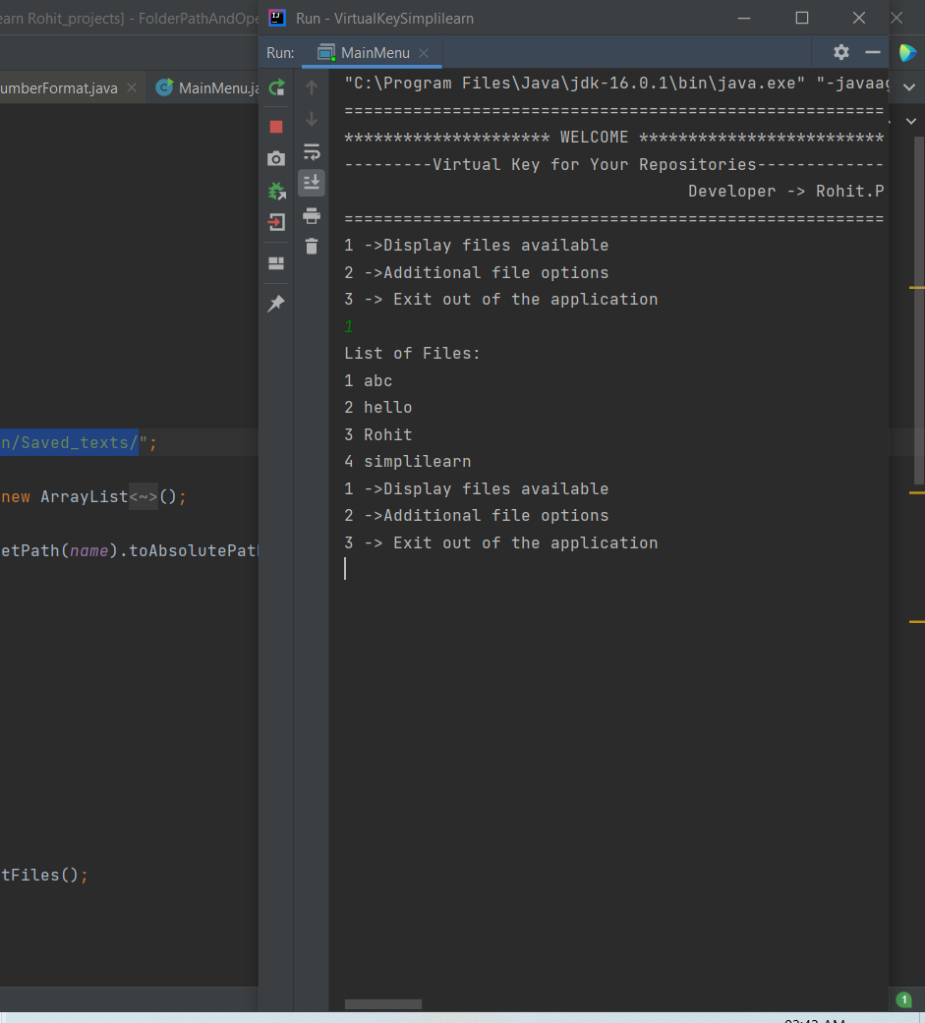

Once the user selects the first option then all the files are listed the option again shows up and as user selects second options it proceeds to show below options

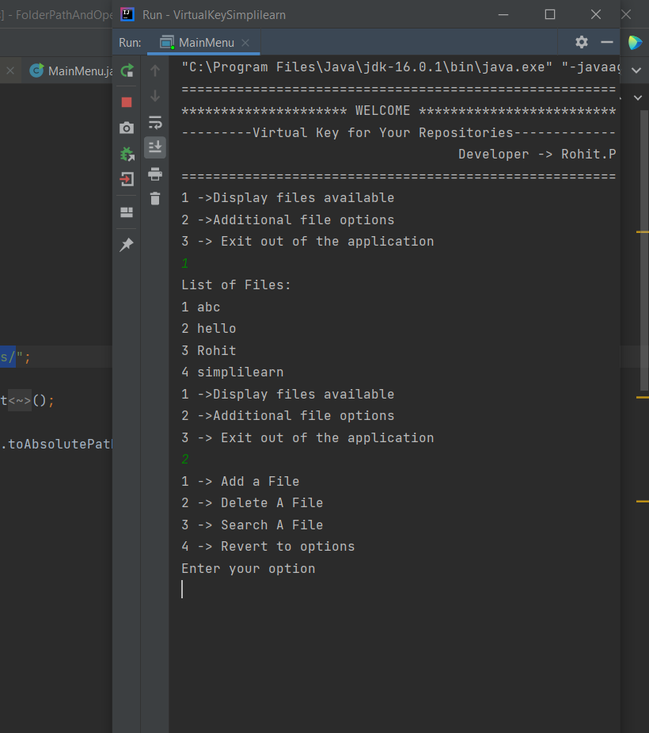

**Adding a file:**

As the user selects the first option they will be asked to name the files before creations

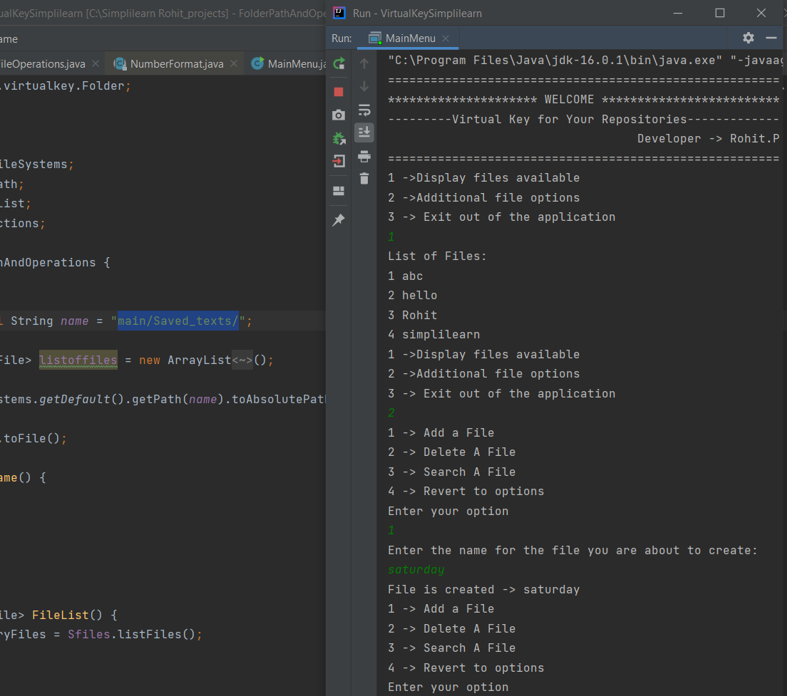

After successful creation of the file it displays the messages file is created with file name

**Deleting a file:**

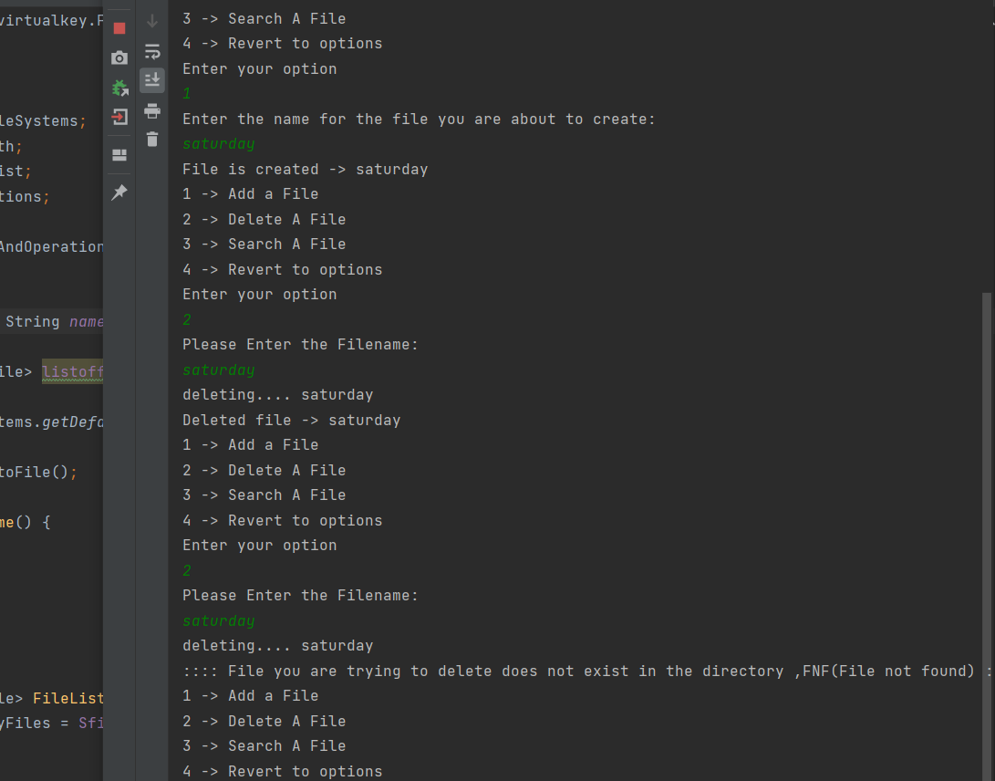

This help the user to delete a specified file also if the file is not present then it displays relevant message on screen

**Searching for file**

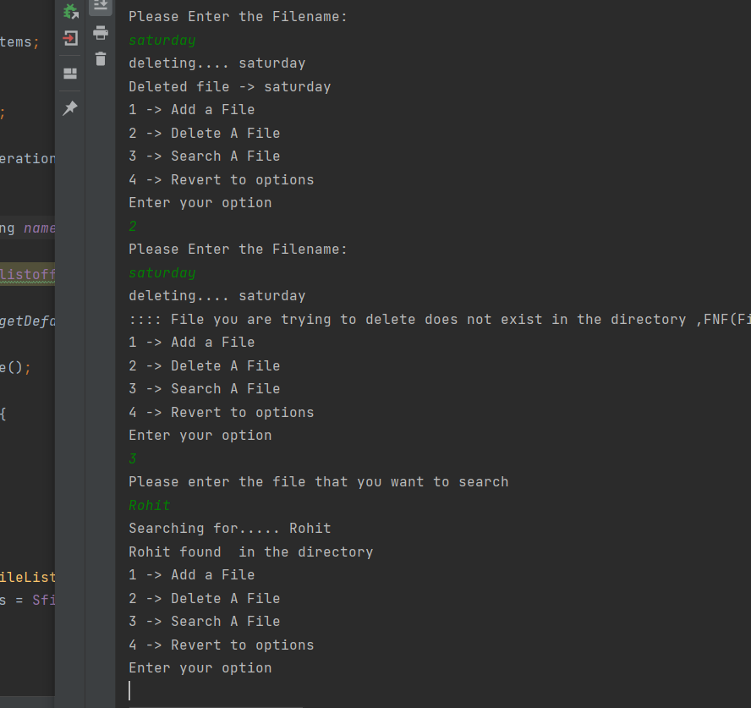

User can search for the files its then loops through the collection of arraylist and check for matches with equals and returns a message

Final options shows main options and the third option in main exists the program

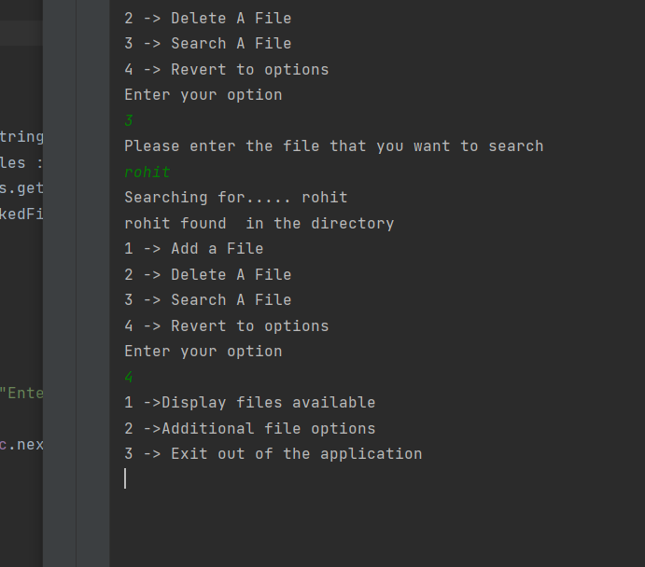

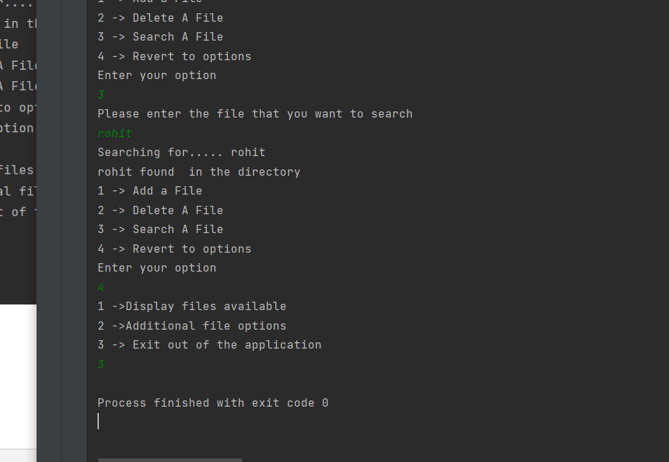

**Time duration in completion**

It took about 3 sprints , in each observation of flow of the programme the

Expected bugs and exception handling were taken into considerations and

Finalisation of code logic .

**Java concepts being user are**

Exception handling(try catch block while creating file) , collections(array list, and sorting used ) , interface, files(concept of I/O) etc.

**Source code briefing**

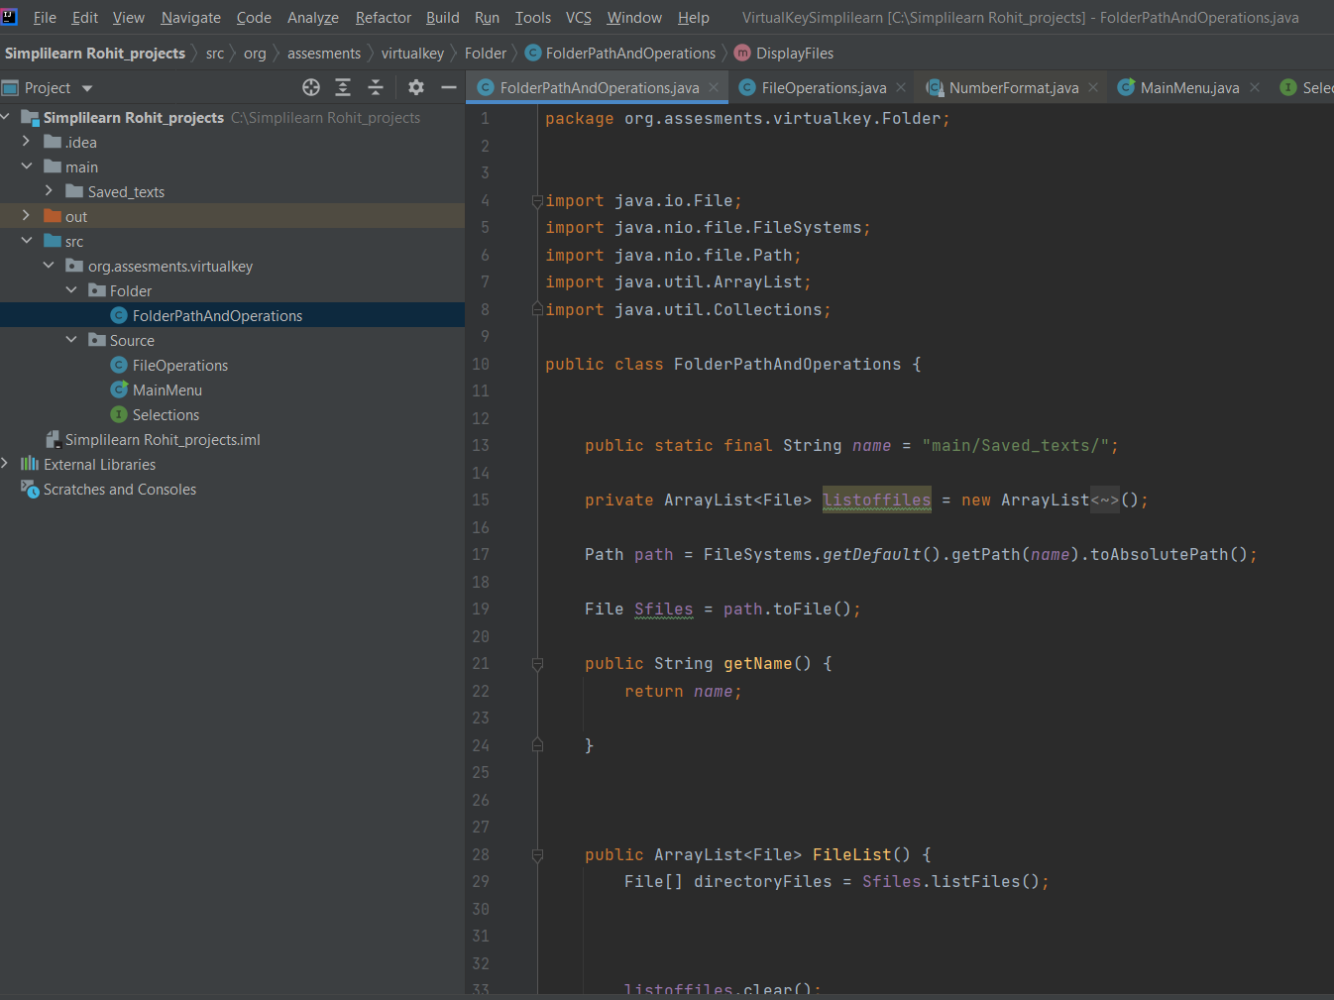

FolderPathAndOperations consist of file list method which stores the file objects into arraylist and performs sorting operations with collection.sort() function and returns a list.

Paths is set as defaulted to workspace locations

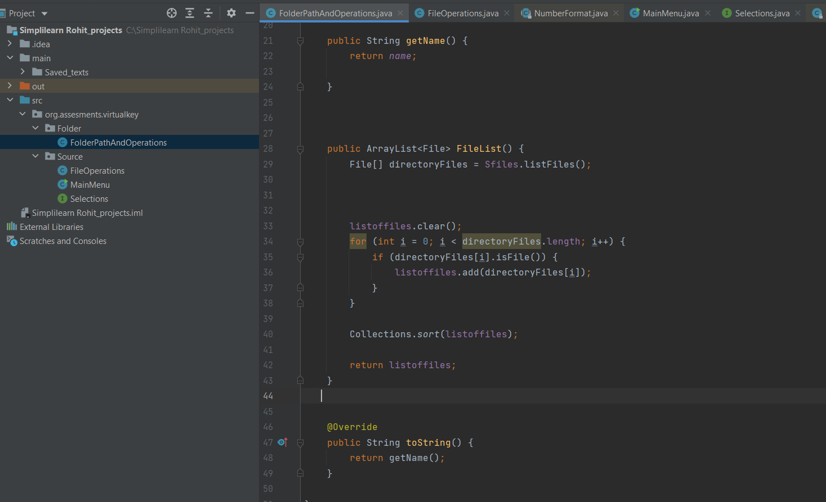

toString is overridden inorder to get the files names when user wishes to check files names in list

Another class fileoperations implementing selections interface is created

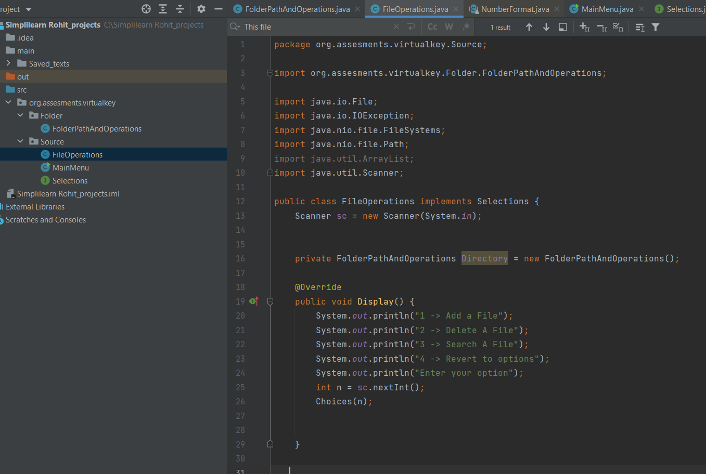

The objective of this class is to perform file creation deletions and additions

Findfiles methods is used in all methods as it checks for file existance in directory before proceeding with file operations

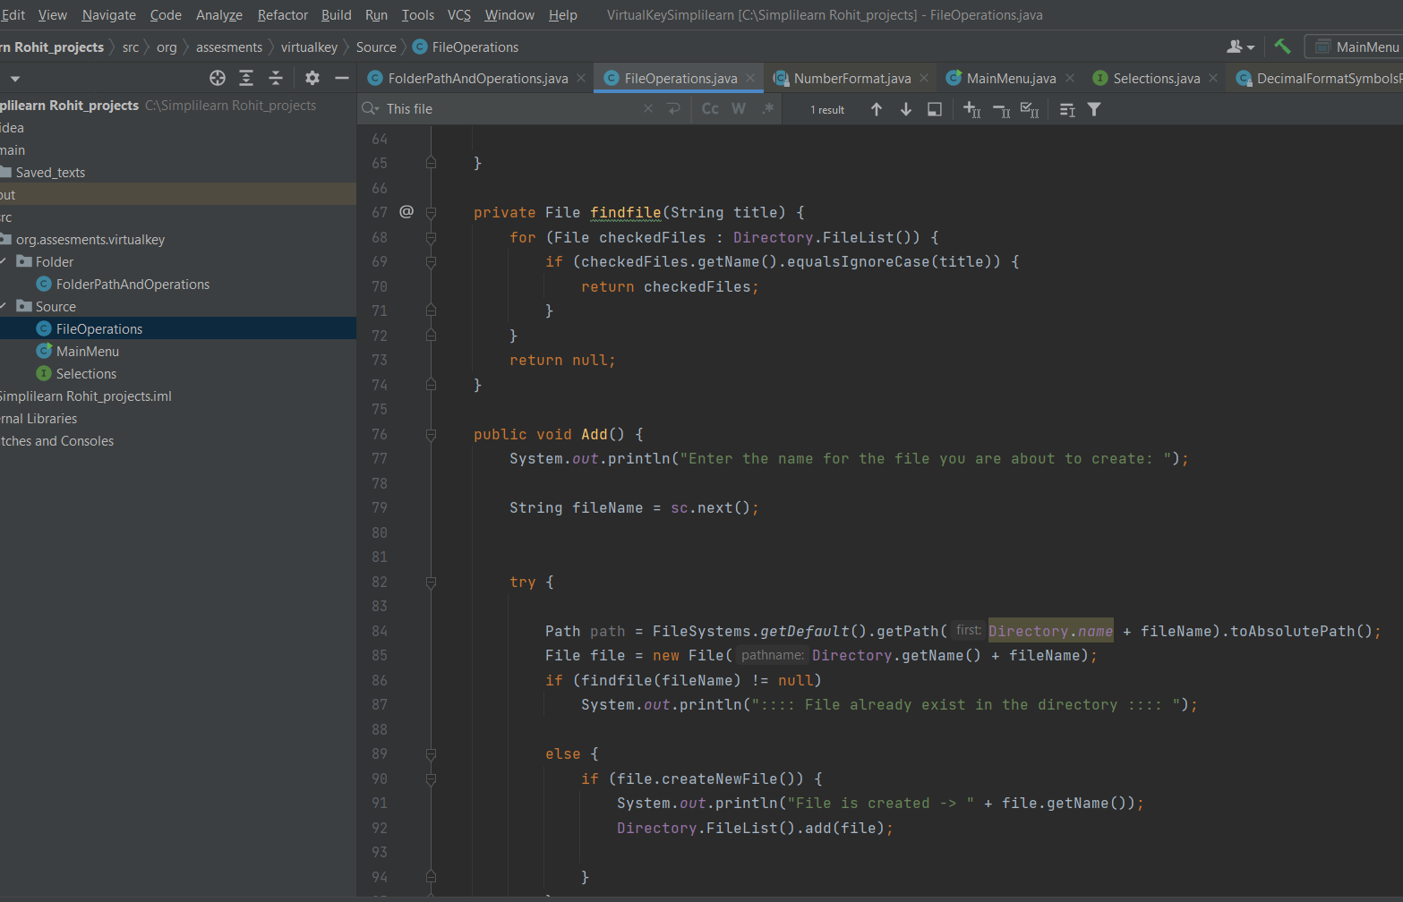

equalsIgnoreCase is specifically used so as to avoid case sensitivity.

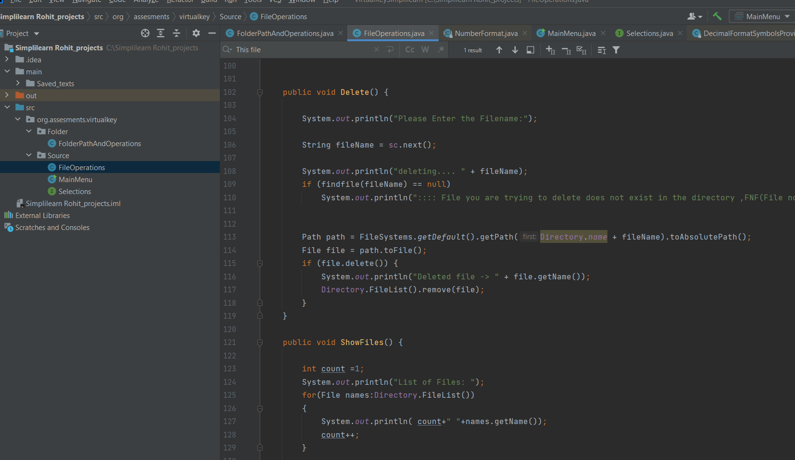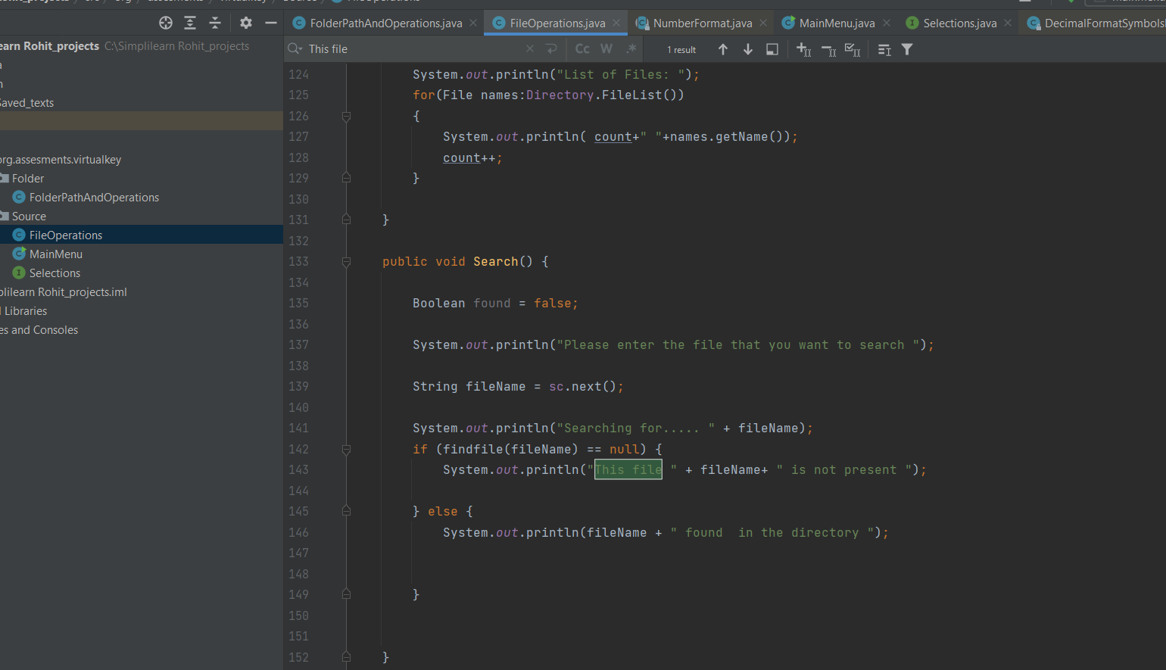

The MainMenu class shows the welcome window and options

